COLLEGE OF COMPUTER STUDIES AND MULTIMEDIA ARTS

IT0049
(WEB SYSTEM TECHNOLOGIES)

TECHNICAL FORMATIVE ASSESSMENT
3

MAKING IT EDITABLE: FORMS, VALIDATION, AND FILE UPLOAD

Student Name / Group Name:
Members (if Group):
  Name | Role
Section:
Professor:

PROGRAM OUTCOME/S (PO) ADDRESSED BY THE LABORATORY EXERCISE
- Design, implement and evaluate computer-based systems or applications to meet desired needs and requirements. [PO: C]

COURSE LEARNING OUTCOME/S (CLO) ADDRESSED BY THE LABORATORY EXERCISE
- Apply advanced web development principles in creating, debugging, validating, and securing database-backed web applications. [CLO: 2]

INTENDED LEARNING OUTCOME/S (ILO) OF THE LABORATORY EXERCISE
At the end of this exercise, students must be able to:
- Build and validate HTML forms for creating new records.
- Redisplay a form with validation errors and the user's previously entered values.
- Implement an edit and update workflow for existing records.
- Accept, validate, prepare, and store an uploaded image file, saving only its filename in the database.

BACKGROUND INFORMATION
A read-only application is only half useful. This activity adds the ability to create and edit records through validated forms — rejecting bad input instead of trusting it — and introduces file upload, a common requirement for anything involving user avatars or product images. CodeIgniter's validation rules, getFile() method, and Image service handle these concerns without changing the main upload workflow.

GRADING SYSTEM / RUBRIC
CRITERIA | Description
Functionality & Requirements Completeness (40 points max) | All required pages and features are present and work as specified in the activity instructions.
Code Structure & Organization (25 points max) | Controllers, models, and views are separated correctly and follow the framework's conventions; code is readable and sensibly named.
Form Validation & File Handling (20 points max) | Forms reject invalid input with clear error messages and preserve the user's entries on redisplay; the uploaded file is validated by type and size, prepared for display, stored safely, and only its filename is saved to the database.
Documentation & Submission Quality (15 points max) | The GitHub repository is organized and complete, the README explains how to set up and run the project, and the hosted link is live and matches the submitted code.

LABORATORY ACTIVITY
Extend the POS application from TFA2 with the ability to create and edit customer and user accounts, and add avatar upload with display-ready image preparation for user accounts.
- Add a New Customer form (/customers/new) that validates required fields (full name required, email required and valid) before inserting a record.
- Add a New User form (/users/new) that validates required fields (username required and unique, full name required) before inserting a record.
- Add edit pages for both customer and user accounts that pre-fill the form with the existing record's data and update it on submit.
- Add an avatar column to the users table. On the user edit form, add a file input for a profile picture; validate that the uploaded file is a JPG or PNG no larger than 2MB, prepare a display-ready copy or thumbnail, store it in a public uploads folder, and save only the filename in the avatar column.
- Display each user's prepared avatar or thumbnail on the User Accounts listing page (fall back to a placeholder image if none was uploaded).

Submission Requirements:
- A link to a GitHub repository containing your raw project files, including your database export.
- A link to your hosted, working version of the application.

IMPLEMENTATION OUTPUT
The TFA3 requirements were implemented in the existing CodeIgniter 4 project without removing the former task-management and coffeehouse pages. Validated customer and user create/edit workflows now coexist with the preserved legacy staff directory.
Repository: https://github.com/Mimiyora/Tahanan
Hosted application: https://tahanan-pos.onrender.com
Database and file handling: The users table includes a nullable avatar filename. JPG and PNG uploads are limited to 2 MB, cropped to a 320 x 320 display image, saved under public/uploads/avatars, and represented in the database by filename only.
Verification: All 13 required and preserved GET routes returned HTTP 200 in local browser QA. Invalid values were rejected while old input remained visible. Valid create and update actions persisted in the QA database. The automated suite passed 16 tests with 73 assertions.
Route and behavior verification
Route | Purpose | Verified result
GET /customers | Customer listing | Loaded seeded records, search, create link, edit links, and the inserted Marisol Torres record.
GET /customers/new  POST /customers | Create customer | Required name and valid email rules rejected bad input; valid data inserted a seventh QA customer.
GET /customers/{id}/edit  POST /customers/{id} | Edit customer | Existing values were pre-filled and the update endpoint persisted changes.
GET /users | User listing | Displayed the bundled placeholder or prepared avatar, account data, and edit links.
GET /users/new  POST /users | Create user | Duplicate username was rejected; a unique Leah Bautista account was inserted.
GET /users/{id}/edit  POST /users/{id} | Edit and upload | Selected PNG passed type/size validation, was prepared to 320 x 320, and its generated filename was stored.
GET /coffeehouse/team | Legacy page | All six original staff records remained available through a separate route and navigation link.
/, /tasks, /profile, /about,  /coffeehouse, /coffeehouse/about | Preserved pages | Every former route returned HTTP 200 with the existing current-date task behavior intact.

Customer Accounts /customers
Purpose: Lists all customer records and provides search, create, and per-record edit actions.
Verified behavior and result: The successful create redirect displays confirmation, the count increased from six to seven, and Marisol Torres appears with the submitted email and phone number.
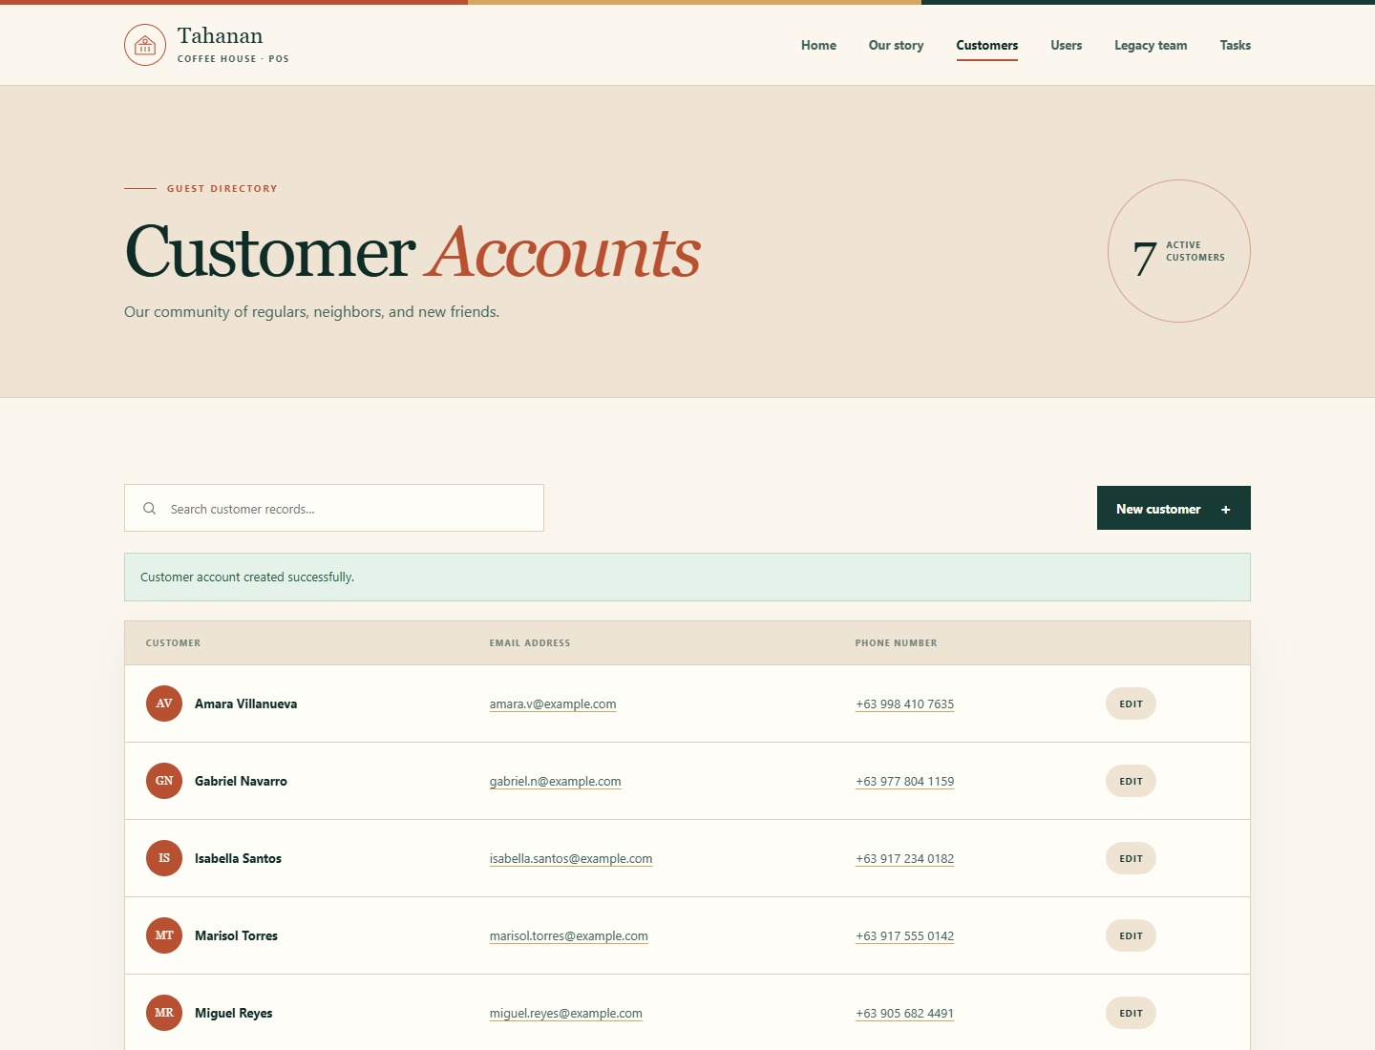
Figure 1. Customer listing after a validated database insert.

New Customer /customers/new
Purpose: Collects the required full name and email plus an optional phone number for a new customer.
Verified behavior and result: The server-backed form presents required-field guidance and posts to the explicit customer create route.
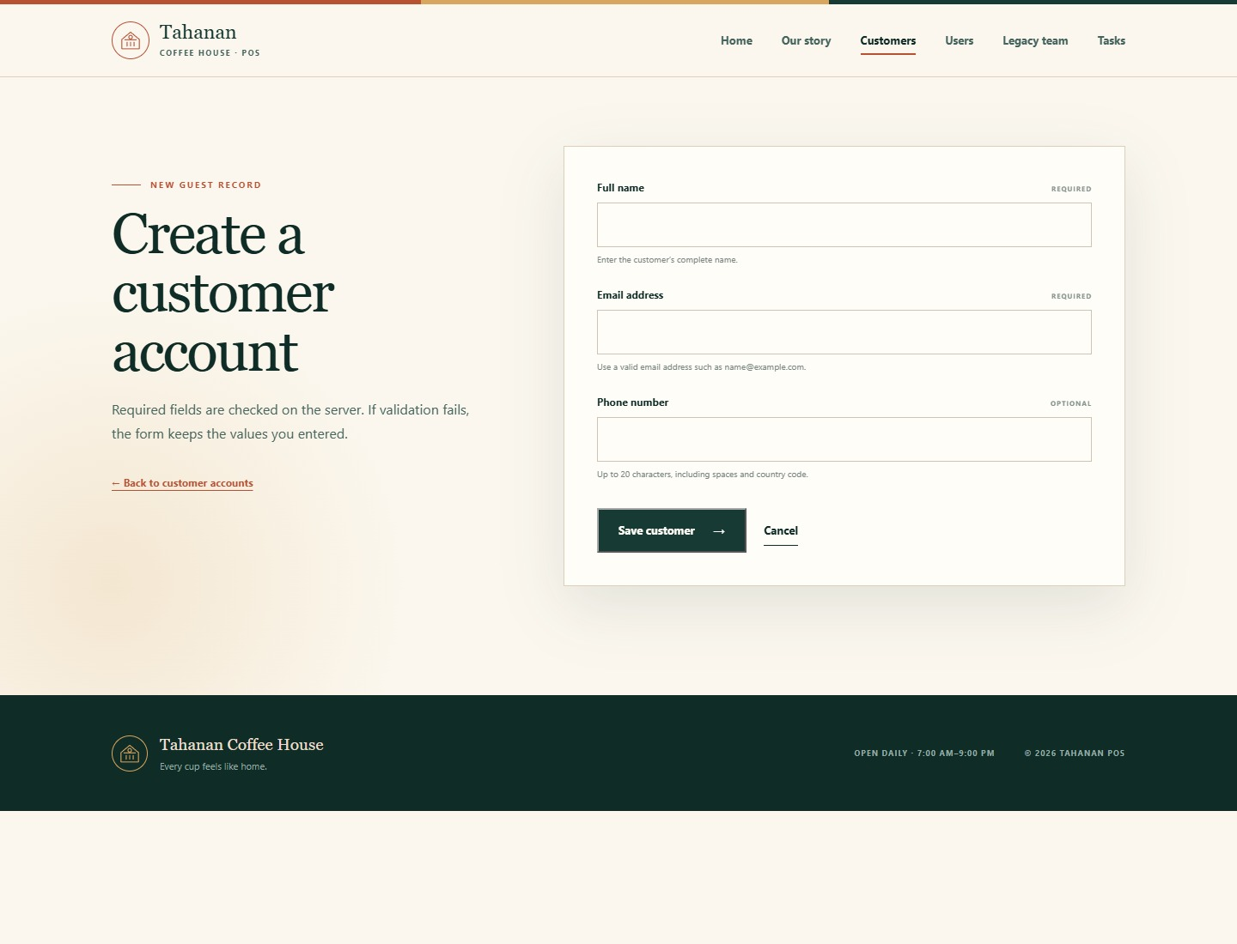
Figure 2. New Customer form before submission.

Customer Validation /customers/new
Purpose: Shows invalid input next to the field and prevents an incomplete or malformed record from being inserted.
Verified behavior and result: The invalid email was rejected, while Marisol Torres and the entered phone number remained populated after redisplay.
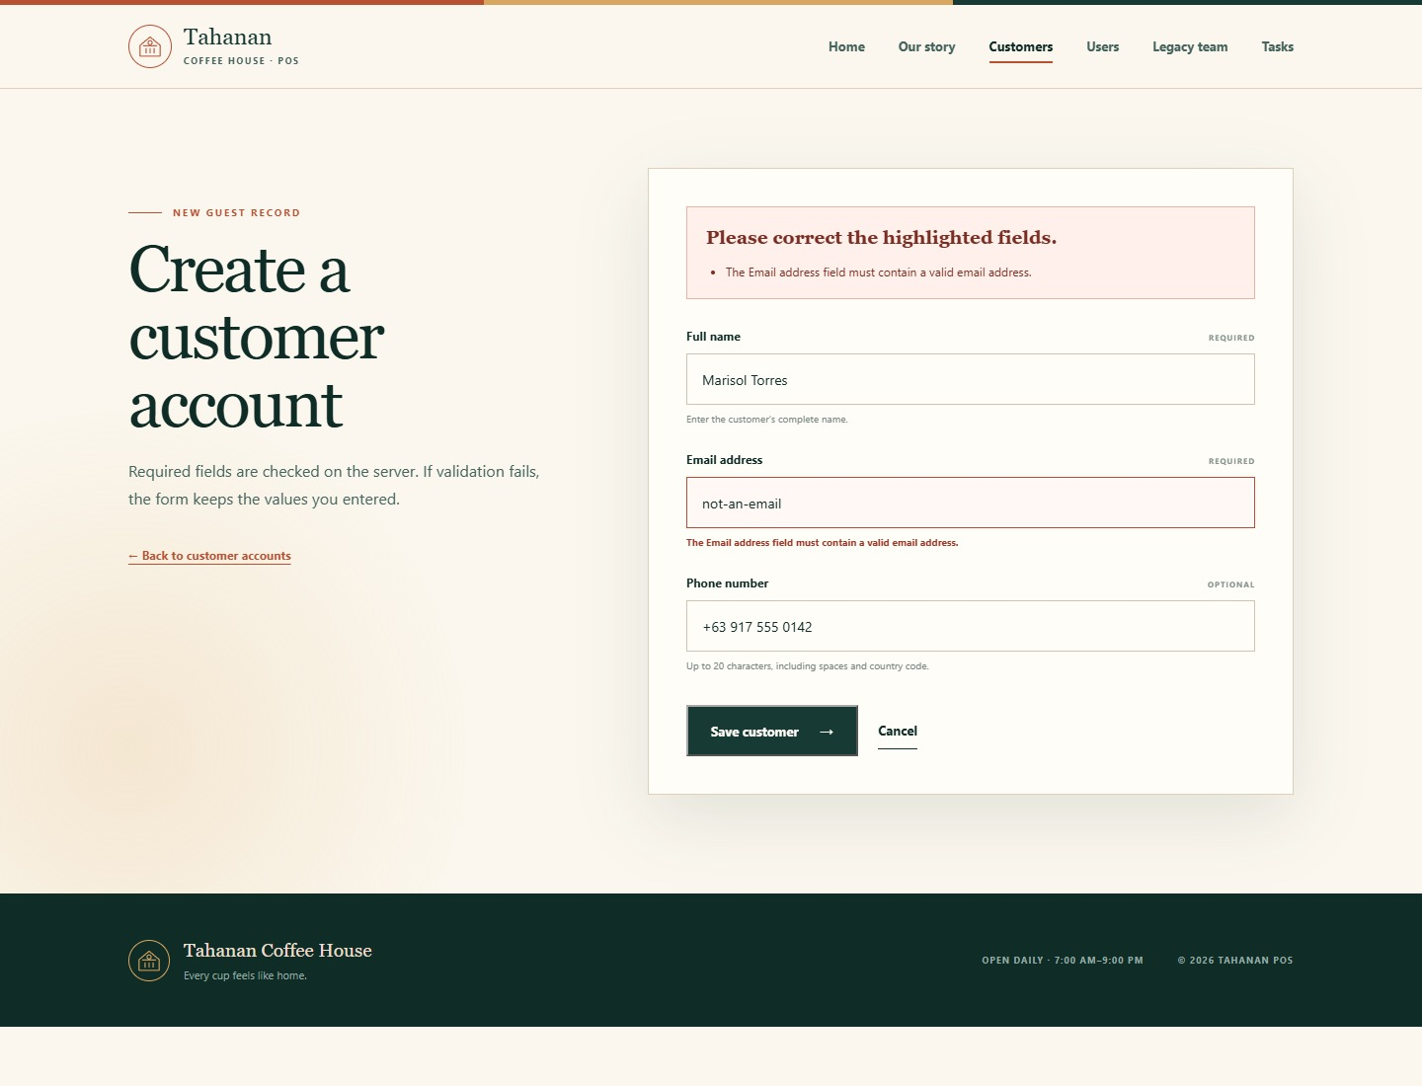
Figure 3. Customer form validation with preserved input.

Edit Customer /customers/7/edit
Purpose: Loads an existing customer into a pre-filled form for update.
Verified behavior and result: The newly inserted customer record was retrieved by ID and all saved values appeared in the corresponding inputs.
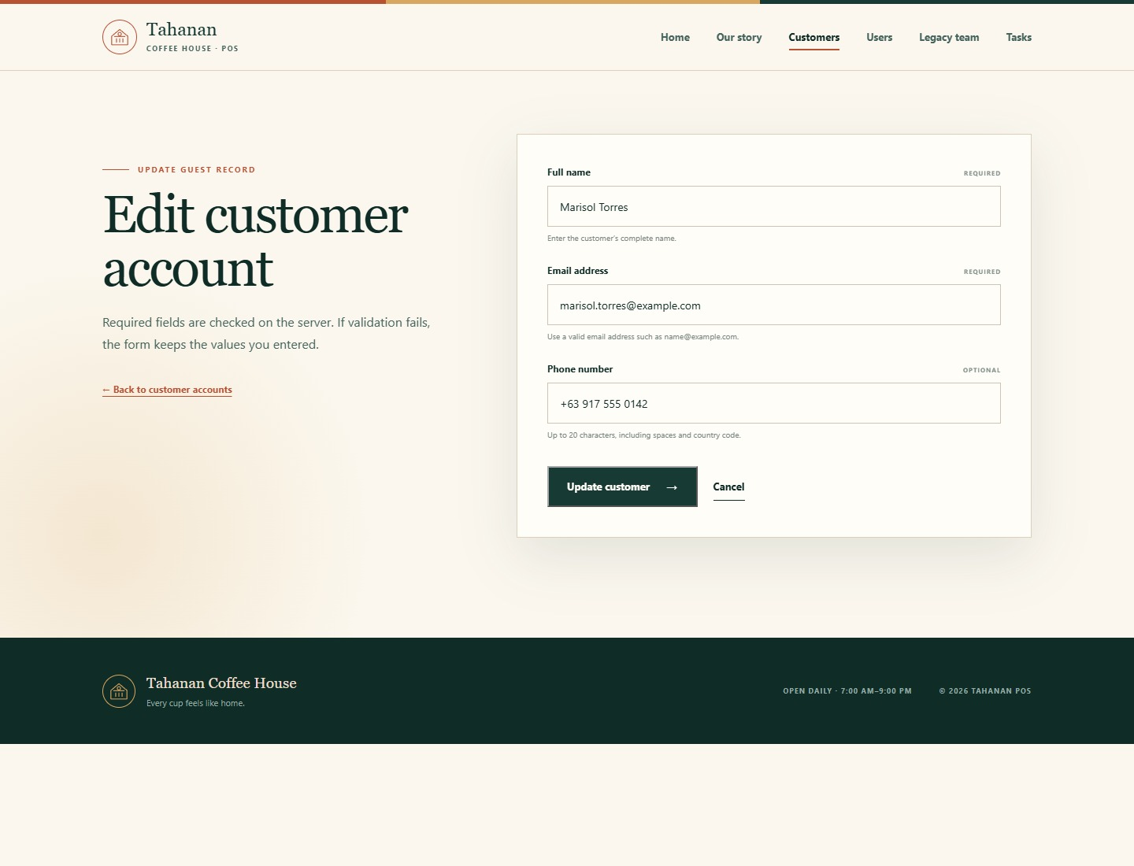
Figure 4. Pre-filled customer edit workflow.

User Accounts /users
Purpose: Lists managed user accounts and displays a safe fallback image when no avatar filename exists.
Verified behavior and result: Gerard Doroja appears with the bundled placeholder, while the six former staff records remain linked from a separate legacy section.
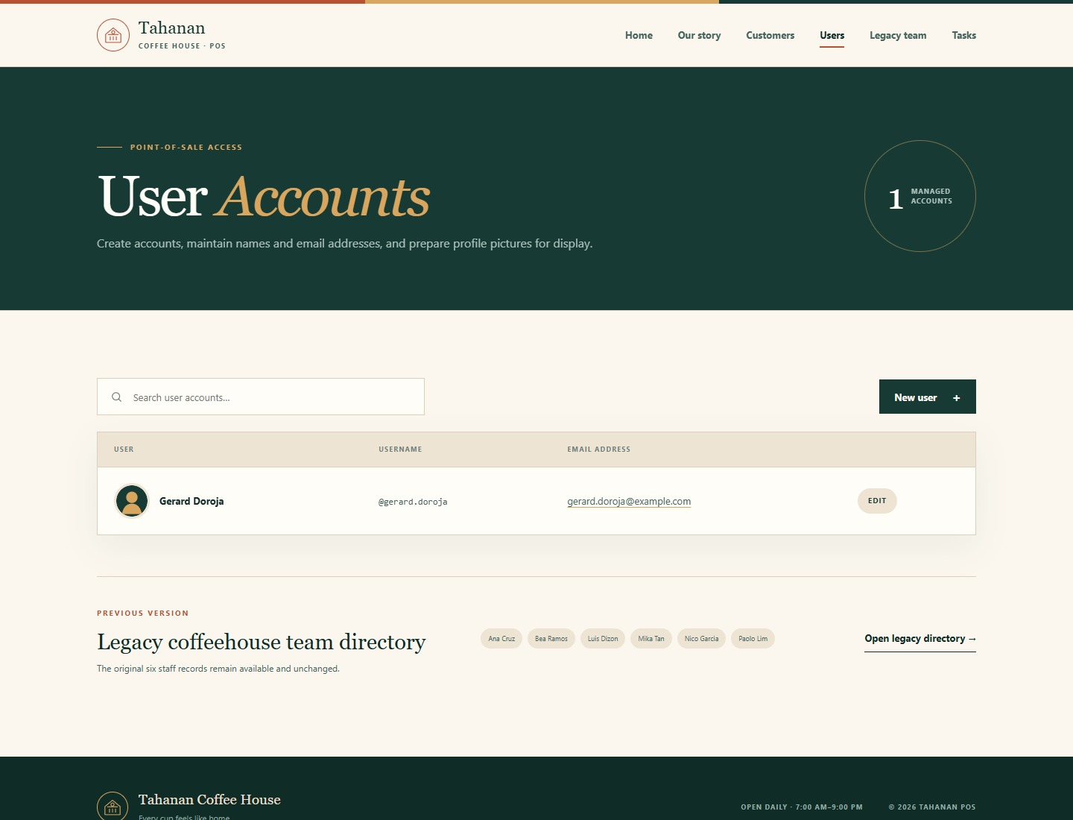
Figure 5. User listing with placeholder avatar and preserved legacy access.

New User Validation /users/new
Purpose: Creates point-of-sale users while enforcing a required, unique username and required full name.
Verified behavior and result: The duplicate gerard.doroja username was rejected and the full name and email remained populated for correction.
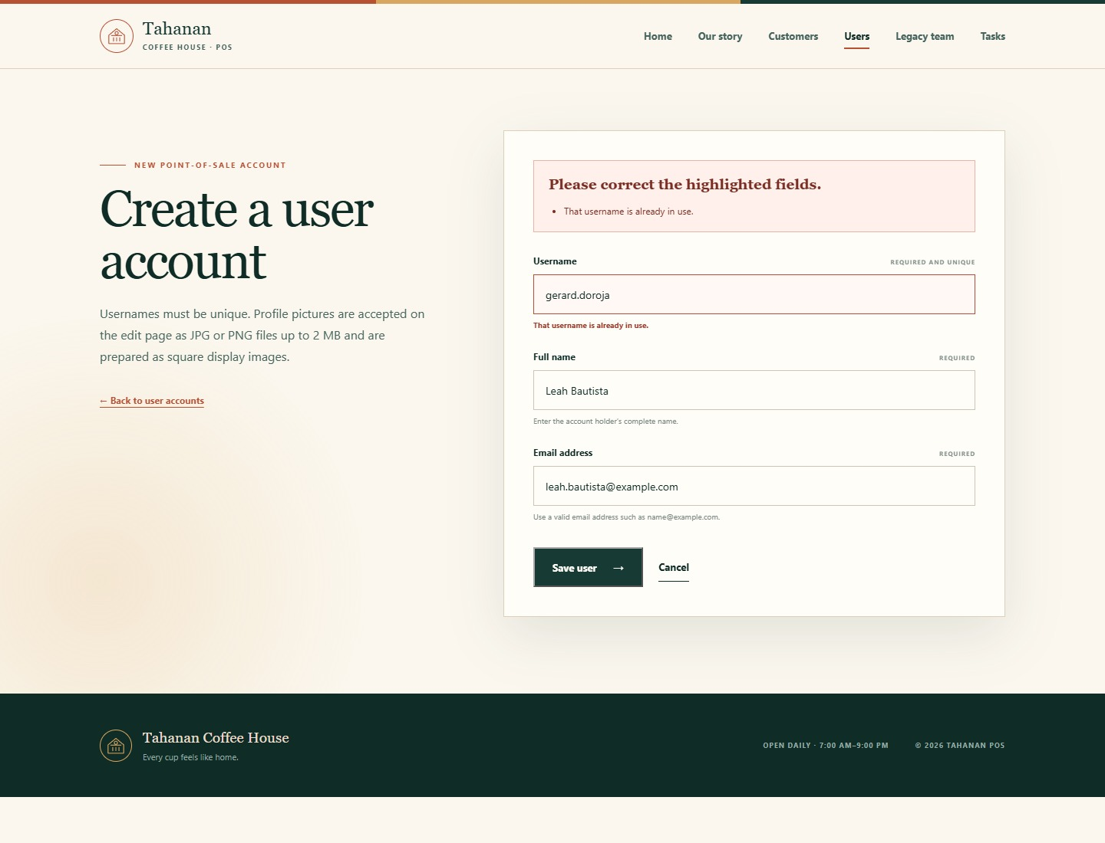
Figure 6. Unique-username validation with preserved user input.

Edit User and Avatar /users/2/edit
Purpose: Updates account data and accepts an optional JPG or PNG profile picture up to 2 MB.
Verified behavior and result: The form was pre-filled for Leah Bautista and the valid qa-avatar.png file was selected for display preparation.
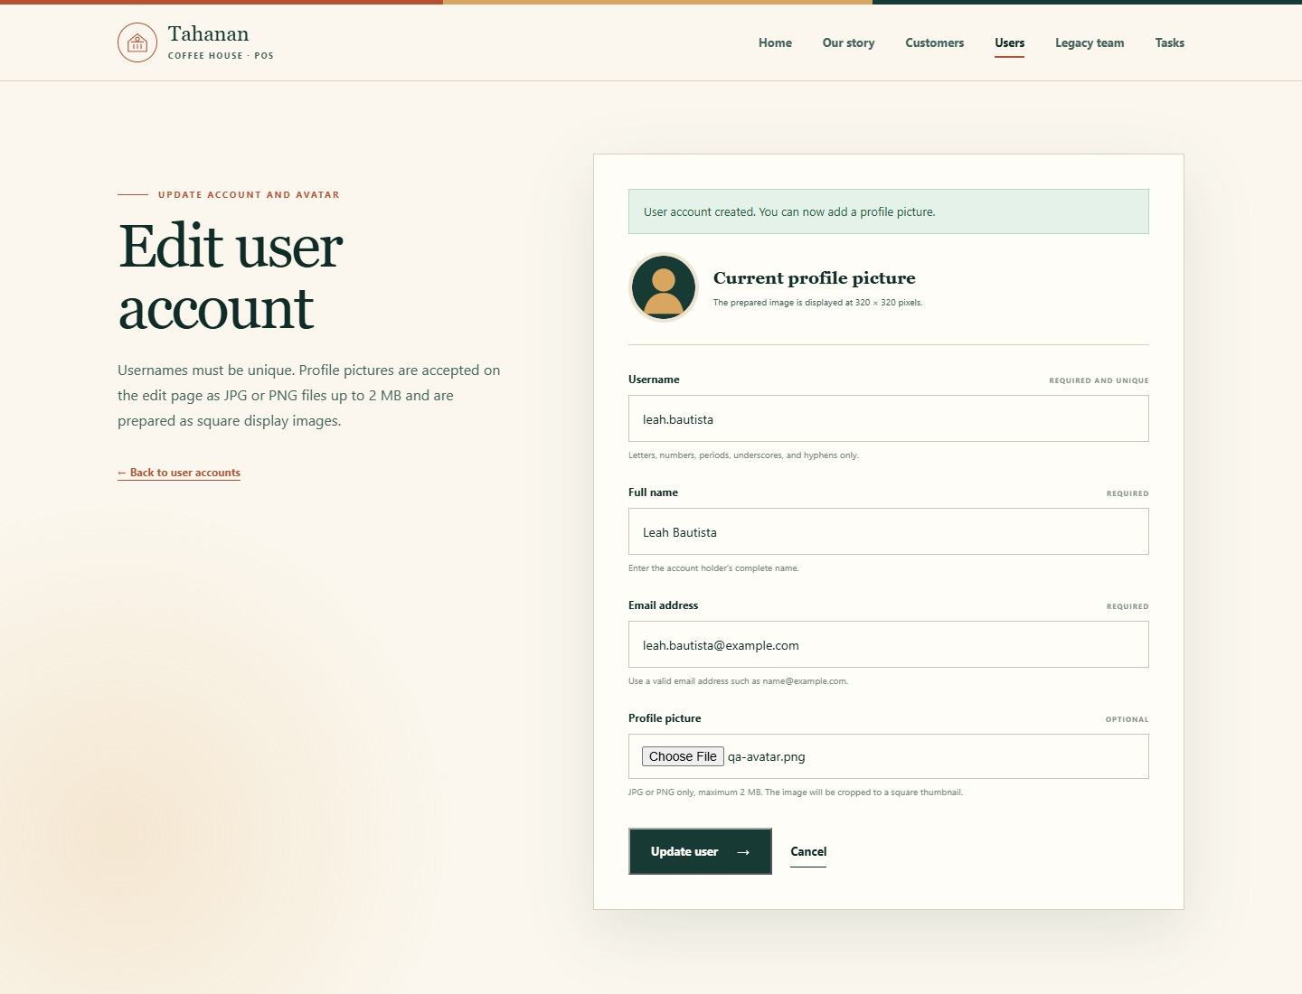
Figure 7. Pre-filled user edit form with a selected avatar file.

User Accounts After Upload /users
Purpose: Displays each user's prepared profile image or the fallback placeholder on the account listing.
Verified behavior and result: The upload was cropped to 320 x 320 pixels, saved as a generated PNG filename, and displayed for Leah Bautista; only that filename was stored in users.avatar.
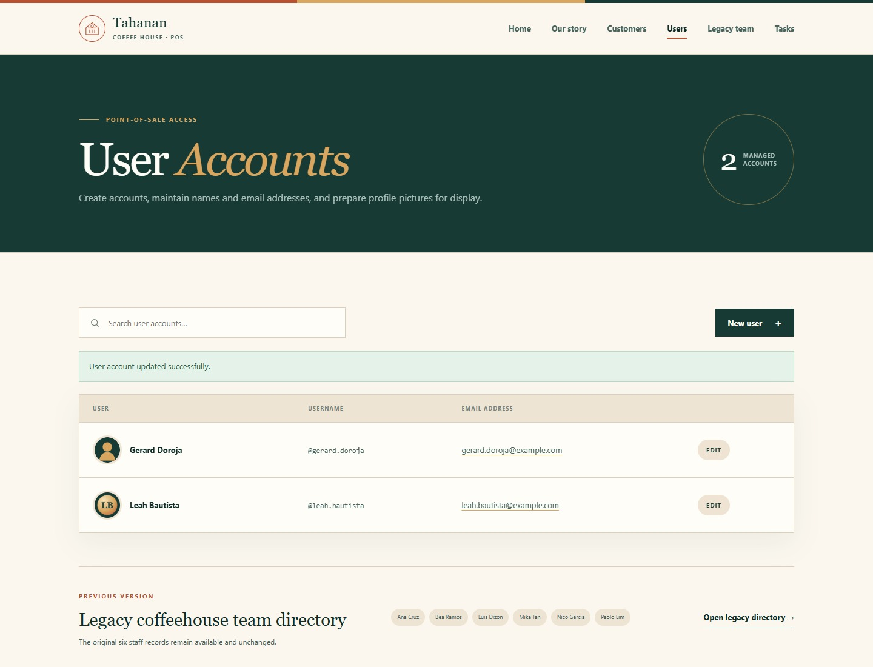
Figure 8. Prepared avatar displayed from the stored filename.

Legacy Coffeehouse Team /coffeehouse/team
Purpose: Keeps the former six-record team directory accessible independently from the new editable user accounts.
Verified behavior and result: All six seeded staff members render from staff_members with their usernames and original dates.
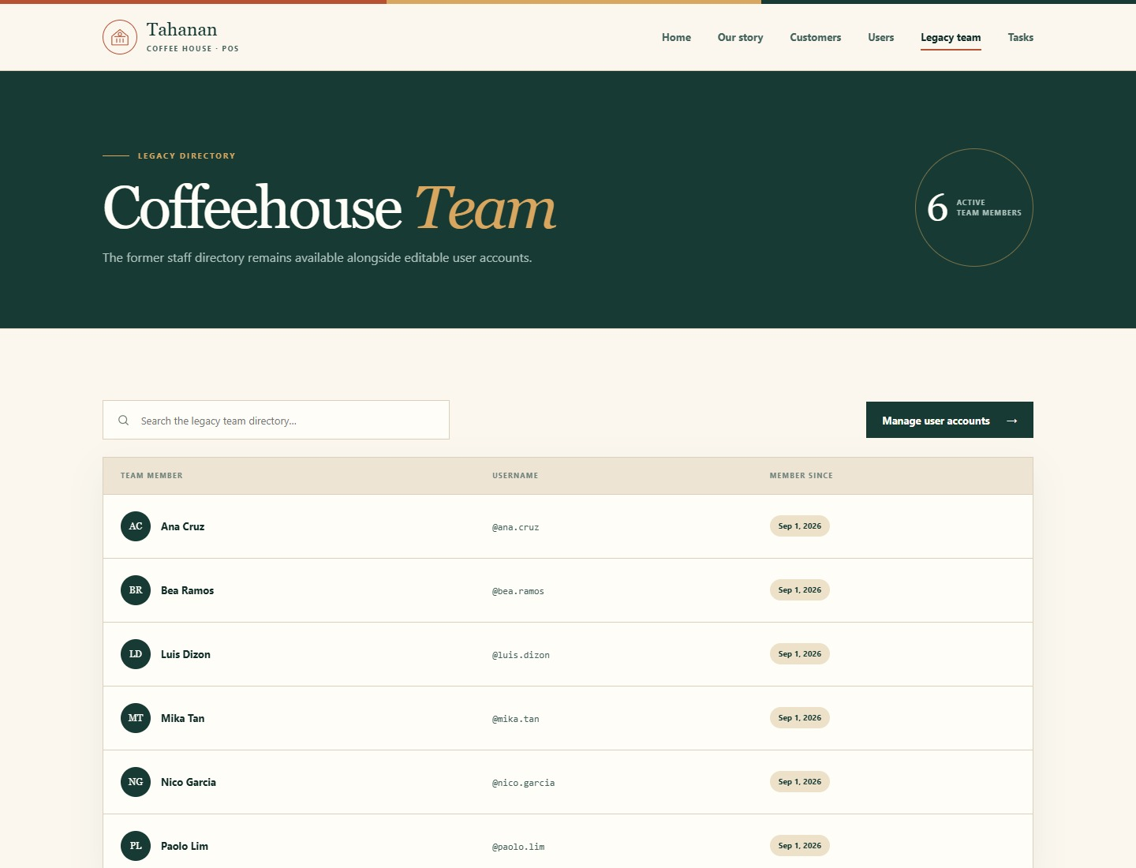
Figure 9. Preserved legacy staff page on its separate route.

Responsive User Accounts /users
Purpose: Provides the same account-management entry points on a narrow mobile viewport.
Verified behavior and result: The navigation collapses to a menu button, the hero content reflows, and search, create, and record cards remain readable at 390 pixels wide.
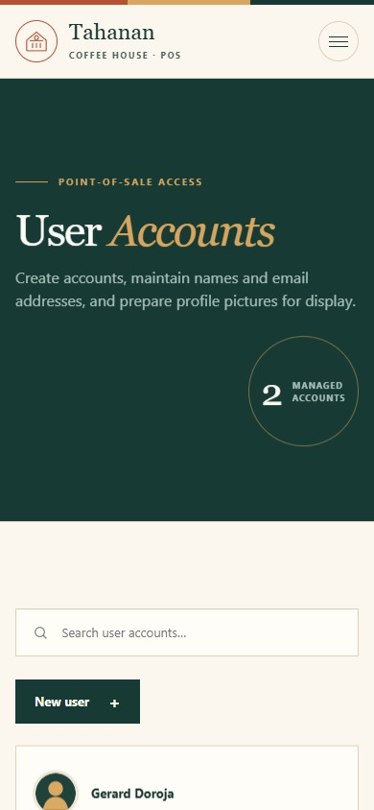
Figure 10. User Accounts responsive layout at 390 x 844 pixels.

REFERENCES
- CodeIgniter User Guide. Validation. https://codeigniter4.github.io/userguide/libraries/validation.html
- CodeIgniter User Guide. File Uploads. https://codeigniter4.github.io/userguide/libraries/uploaded_files.html

